

**Database Design for Airline Travel Company**

**IST659-Group 8**

**Yuzhou Huang, Yafei Lou, Qingqing Hu**

**12/1/2020**



**Content**

**Project Summary 3**

**Relational Data Model 4**

**Data Dictionary 7**

**Business Rules 13**

**Database System Structure 13**

**SQL Codes 14**

**Major Data Questions 19**

**Interface Implementation - Forms and Reports 27**

**Project Summary:**

Air travel shopping is a basic service in modern society. People can observe, search, compare and book flight tickets. Therefore, a modern database for Airline Travel company should stores customer information, financial data, flight history and airline information.

The process is described as follow:

Customers can observe flight information and make purchases of flights on our website. In the database system, customer information is registered by customer because only member customer can make purchase of flights in our website. Once purchase is made, purchase information of customer and flight is stored. If customer stores a flight ticket in the shopping cart, the system store that information as well. For the company, users can view purchase confirmation information. Because purchases are stored, users can analyze sales of each airline and each airline company. Also, flight history information is stored as well. Users can compare each airline’s on-time rate, delay rate, and cancellation rate. Because of the context of COVID-19, the database system also tracks special instruction and requirements related to COVID so that member customers can be better informed.

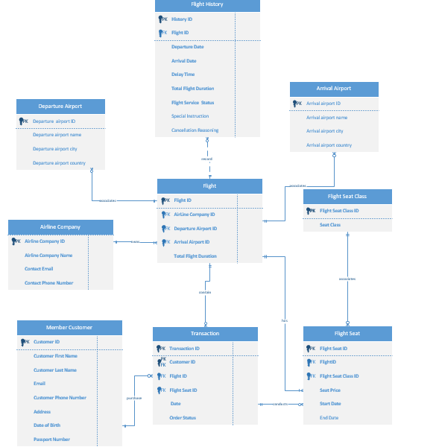**Relational data model**

**Data Dictionary:**

**1. Member Customer**

Records information about the customers of the system

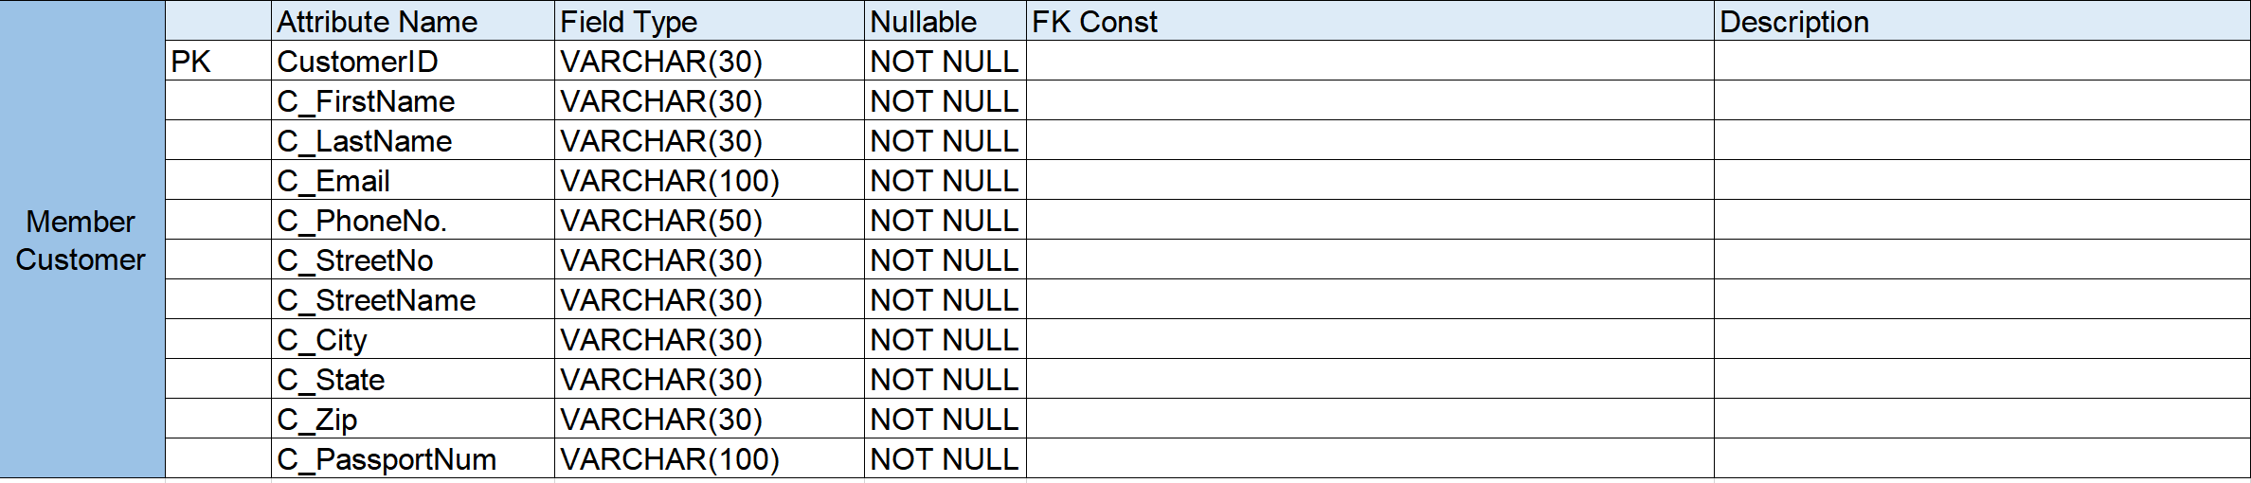

**2. Airline Company**

Stores the airline companies that offer flight service.



1. **Flight**

Provide the relevant information about flights.

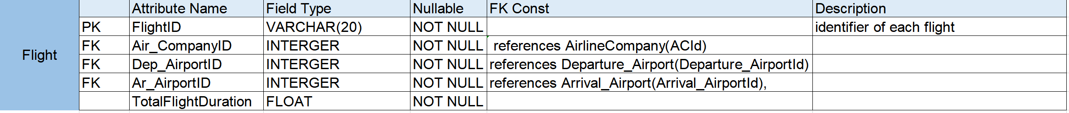

1. **Arrival Airport**

Record the information of airports where flights arrived



1. **Departure Airport**

Record the information of airports where flights departed.



1. **FlightSeat**

Store the price and class for each seat in flights.

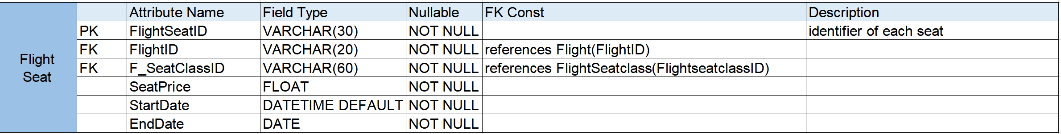

1. **Flight Seat Class**

Store the class of each seat in flights.



1. **Transaction**

Stores the information of transactions, including flight, customer and order status and etc.

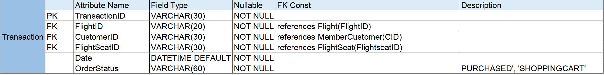

1. **Flight History**

Record the relevant information for each flight in the history, which is convenient for customer or administer to read and search for.

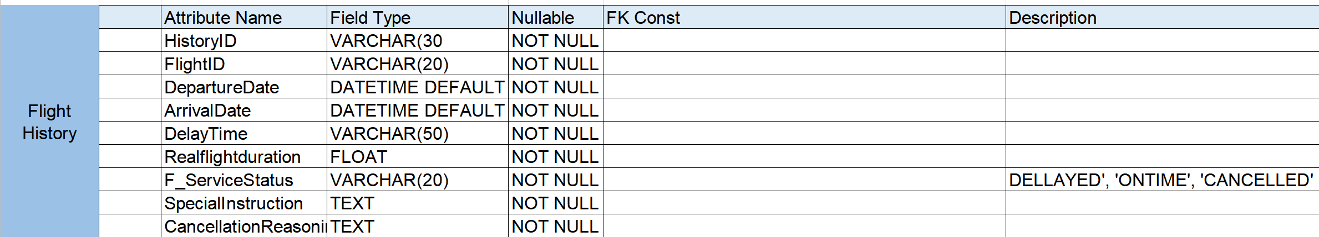

**Business Rules:**

1.Every customer must register before making a purchase.

2.Data cannot be used or shared with third-party without permission.

3.Customer cannot refund tickets 24h before departure.

4.The platform updates flight ticket and flight information instantly.

5.Users cannot view queries in Access and access to SQL database.

6. Administrators can view, update, and modify queries in Access.

7. Flight information must be associated with airline companies.

8. Customer information must be protected.

**Database System Infrastructure**

We used the following tools to create and implement this project:

1. We created entity relationship diagram by using MS Visio.

2. We used SQL Server as the database that stored all the tables and data. We created and populate tables and implement view and case in SQL.

3. We used MS Access to create the interface for the system and linked the SQL data. Then, we created forms to take user input and display necessary information. We also used MS Access to create reports based on our data.

**SQL Code:**

drop table FlightTransaction

drop table MemberCustomer

drop table FlightSeat

drop table FlightSeatclass

drop table FlightHistory

drop table Flight

drop table Arrival_Airport;

drop table Departure_Airport

drop table AirlineCompany

create table Arrival_Airport (

Arrival_AirportId Integer not null,

Arrival_AirportName varchar(100) not null,

Arrival_AirportCity varchar(30) not null,

Arrival_AirportCountry varchar(30) not null,

constraint Arrival_Airport_PK Primary Key (Arrival_AirportId)

);

create table Departure_Airport (

Departure_AirportId Integer not null,

Departure_AirportName varchar(100) not null,

Departure_AirportCity varchar(30) not null,

Departure_AirportCountry varchar(30) not null,

constraint Departure_Airport_PK Primary Key (Departure_AirportId)

);

create table AirlineCompany (

ACId Integer not null,

ACName varchar(30) not null,

ACEmail varchar(30) not null,

ACPhone varchar(30) not null,

constraint AC_PK Primary Key (ACID)

);

create table MemberCustomer(

CID varchar(30) not null,

CFName varchar(30) not null,

CLName varchar(30) not null,

CPhone varchar(50) not null,

CEmail varchar(100) not null,

CStreetNo varchar(30) not null,

CStreetName varchar(30) not null,

CCity varchar(30) not null,

CState varchar(30) not null,

CZip varchar(30) not null,

CBday varchar(30) not null,

CPassportNum varchar(100) not null,

constraint MemberCustomer_PK Primary Key (CID)

);

create table Flight(

FlightID VARCHAR(20) not null,

ACId Integer not null,

DepartureAirportId Integer not null,

ArrivalairportId Integer not null,

Totalflightduration FLOAT not null,

constraint Flight_PK Primary Key(FlightID),

constraint Flight_FK1 Foreign Key (ACId) references AirlineCompany(ACId),

constraint Flight_FK2 Foreign Key (DepartureAirportId) references Departure_Airport(Departure_AirportId),

constraint Flight_FK3 Foreign Key (ArrivalairportId) references Arrival_Airport(Arrival_AirportId),

);

create table FlightHistory(

HisotryID varchar(30) not null,

FlightID VARCHAR(20) not null,

Departuredate datetime default getdate() not null,

Arrivaldate datetime default getdate() not null,

DelayTime varchar(50) not null,

Realflightduration FLOAT not null,

Flightservicestatus varchar(20) not null check (Flightservicestatus in ('Delayed','On Time','Cancelled')),

Specialinstruction text,

CancellationReasoning text,

constraint FH_PK Primary Key(HisotryID),

constraint FH_FK Foreign Key (FlightID) references Flight(FlightID)

);

create table FlightSeatclass(

FlightseatclassID varchar(60) not null,

Seatclass varchar(60) not null,

constraint FlightSeatclass_PK Primary Key(FlightseatclassID)

create table FlightSeat(

FlightseatID varchar(30) not null,

FlightID VARCHAR(20) not null,

FlightseatclassID varchar(60) not null,

Seatprice float not null,

Startdate datetime default getdate() not null,

Enddate date,

constraint Flightseat_PK Primary Key (FlightseatID),

constraint Flightseat_FK1 Foreign Key (FlightID) references Flight(FlightID),

constraint Flightseat_FK2 Foreign Key (FlightseatclassID) references FlightSeatclass(FlightseatclassID)

);

create table FlightTransaction(

TransactionID varchar(30) not null,

FlightID VARCHAR(20) not null,

CID varchar(30) not null,

FlightseatID varchar(30) not null,

FlightDate datetime default getdate() not null,

OrderStatus varchar(60) not null check (OrderStatus in ('Purchased','ShoppingCart')),

constraint transcation_PK Primary Key (TransactionID),

constraint FlightTransaction_FK1 Foreign Key (FlightID) references Flight(FlightID),

constraint FlightTransaction_FK2 Foreign Key (CID) references MemberCustomer(CID),

constraint FlightTransaction_FK3 Foreign Key (FlightseatID) references FlightSeat(FlightseatID),

);

INSERT INTO Arrival_Airport (Arrival_AirportId, Arrival_AirportName, Arrival_AirportCity, Arrival_AirportCountry)

VALUES (1, 'Beijing Capital International Airport', 'Beijing', 'China')

INSERT INTO Arrival_Airport (Arrival_AirportId, Arrival_AirportName, Arrival_AirportCity, Arrival_AirportCountry)

VALUES (2, 'New York JFK International Airport', 'New York', 'USA')

INSERT INTO Arrival_Airport (Arrival_AirportId, Arrival_AirportName, Arrival_AirportCity, Arrival_AirportCountry)

VALUES (3, 'Shanghai Pudong International Airport', 'Shanghai', 'China')

INSERT INTO Arrival_Airport (Arrival_AirportId, Arrival_AirportName, Arrival_AirportCity, Arrival_AirportCountry)

VALUES (4, 'Los Angeles International Airport', 'Los Angeles', 'USA')

INSERT INTO Arrival_Airport (Arrival_AirportId, Arrival_AirportName, Arrival_AirportCity, Arrival_AirportCountry)

VALUES (5, 'Chicago O Hare International Airport', 'Chicago', 'USA')

INSERT INTO Arrival_Airport (Arrival_AirportId, Arrival_AirportName, Arrival_AirportCity, Arrival_AirportCountry)

VALUES (6, 'Shenzhen Bao an International Airport', 'Shenzhen', 'China')

INSERT INTO Arrival_Airport (Arrival_AirportId, Arrival_AirportName, Arrival_AirportCity, Arrival_AirportCountry)

VALUES (7, 'Frankfurt Airport', 'Frankfurt', 'German')

INSERT INTO Arrival_Airport (Arrival_AirportId, Arrival_AirportName, Arrival_AirportCity, Arrival_AirportCountry)

VALUES (8, 'Detroit Metropolitan Wayne County Airport', 'Detroit', 'USA')

INSERT INTO Arrival_Airport (Arrival_AirportId, Arrival_AirportName, Arrival_AirportCity, Arrival_AirportCountry)

VALUES (9, 'San Francisco International Airport', 'San Francisco', 'USA')

INSERT INTO Arrival_Airport (Arrival_AirportId, Arrival_AirportName, Arrival_AirportCity, Arrival_AirportCountry)

VALUES (10, 'Dallas-Fort Worth International Airport', 'Dallas', 'USA')

INSERT INTO Departure_Airport (Departure_AirportId, Departure_AirportName, Departure_AirportCity, Departure_AirportCountry)

VALUES (1, 'Beijing Capital International Airport', 'Beijing', 'China')

INSERT INTO Departure_Airport (Departure_AirportId, Departure_AirportName, Departure_AirportCity, Departure_AirportCountry)

VALUES (2, 'New York JFK International Airport', 'New York', 'USA')

INSERT INTO Departure_Airport (Departure_AirportId, Departure_AirportName, Departure_AirportCity, Departure_AirportCountry)

VALUES (3, 'Shanghai Pudong International Airport', 'Shanghai', 'China')

INSERT INTO Departure_Airport (Departure_AirportId, Departure_AirportName, Departure_AirportCity, Departure_AirportCountry)

VALUES (4, 'Los Angeles International Airport', 'Los Angeles', 'USA')

INSERT INTO Departure_Airport (Departure_AirportId, Departure_AirportName, Departure_AirportCity, Departure_AirportCountry)

VALUES (5, 'Chicago O Hare International Airport', 'Chicago', 'USA')

INSERT INTO Departure_Airport (Departure_AirportId, Departure_AirportName, Departure_AirportCity, Departure_AirportCountry)

VALUES (6, 'Shenzhen Bao an International Airport', 'Shenzhen', 'China')

INSERT INTO Departure_Airport (Departure_AirportId, Departure_AirportName, Departure_AirportCity, Departure_AirportCountry)

VALUES (7, 'Frankfurt Airport', 'Frankfurt', 'German')

INSERT INTO Departure_Airport (Departure_AirportId, Departure_AirportName, Departure_AirportCity, Departure_AirportCountry)

VALUES (8, 'Detroit Metropolitan Wayne County Airport', 'Detroit', 'USA')

INSERT INTO Departure_Airport (Departure_AirportId, Departure_AirportName, Departure_AirportCity, Departure_AirportCountry)

VALUES (9, 'San Francisco International Airport', 'San Francisco', 'USA')

INSERT INTO Departure_Airport (Departure_AirportId, Departure_AirportName, Departure_AirportCity, Departure_AirportCountry)

VALUES (10, 'Dallas-Fort Worth International Airport', 'Dallas', 'USA')

INSERT INTO AirlineCompany (ACId, ACName, ACEmail, ACPhone)

VALUES (1, 'China Airlines', 'ChinaAirlines@163.com', '86-666-666-8888')

INSERT INTO AirlineCompany (ACId, ACName, ACEmail, ACPhone)

VALUES (2, 'United Airlines', 'UnitedAirlines@usa.com', '1-800-864-8331')

INSERT INTO AirlineCompany (ACId, ACName, ACEmail, ACPhone)

VALUES (3, 'Cathay Pacific', 'CathayPacific@cp.com', '1-800-233-2742')

INSERT INTO AirlineCompany (ACId, ACName, ACEmail, ACPhone)

VALUES (4, 'China Southern Airlines', 'skypearl@csair.com', '86-020-8613-4388')

INSERT INTO AirlineCompany (ACId, ACName, ACEmail, ACPhone)

VALUES (5, 'Deutsche Lufthansa AG', 'Lufthansa@deut.com', '1-800-645-3880')

INSERT INTO MemberCustomer (CID, CFName,CLName,CPhone,CEmail,CStreetNo,CStreetName,CCity,CState,CZip,CBday,CPassportNum)

VALUES (1, 'Yun', 'Zhang', 'zhangyun@163.com','315-999-9999','22','main st','Syracuse','NY','13402','June-09-1992','CH1231111')

INSERT INTO MemberCustomer (CID, CFName,CLName,CPhone,CEmail,CStreetNo,CStreetName,CCity,CState,CZip,CBday,CPassportNum)

VALUES (2, 'Meili', 'Wang', 'meiliwang@163.com','315-222-2222','45','John st','Syracuse','NY','13409','March-09-1978','CH1674444')

INSERT INTO MemberCustomer (CID, CFName,CLName,CPhone,CEmail,CStreetNo,CStreetName,CCity,CState,CZip,CBday,CPassportNum)

VALUES (3, 'John', 'Trump', 'trumpjohn@gmail.com','346-222-9999','1','main st','New York','NY','12001','Dec-12-1981','USA333321')

INSERT INTO MemberCustomer (CID, CFName,CLName,CPhone,CEmail,CStreetNo,CStreetName,CCity,CState,CZip,CBday,CPassportNum)

VALUES (4, 'Mary', 'Bullis', 'marybullis@gmail.com','322-111-9999','111','Clinton ave','Chicago','IL','30242','Jan-11-1971','USA322389')

INSERT INTO MemberCustomer (CID, CFName,CLName,CPhone,CEmail,CStreetNo,CStreetName,CCity,CState,CZip,CBday,CPassportNum)

VALUES (5, 'Xiaoli', 'Huang', 'huangxiaoli@gmail.com','605-222-3434','2','star ave','Los Angeles','CA','90055','Feb-16-1995','CH1119389')

INSERT INTO MemberCustomer (CID, CFName,CLName,CPhone,CEmail,CStreetNo,CStreetName,CCity,CState,CZip,CBday,CPassportNum)

VALUES (6, 'Mingbo', 'Li', 'mingbol@gmail.com','535-231-7675','216','elen ave','Los Angeles','CA','90055','Oct-17-1998','CH0248599')

INSERT INTO MemberCustomer (CID, CFName,CLName,CPhone,CEmail,CStreetNo,CStreetName,CCity,CState,CZip,CBday,CPassportNum)

VALUES (7, 'shenjing', 'liu', 'liushenjing@gmail.com','444-444-3434','44','noew ave','Syracuse','NY','13210','Apr-14-1994','CH1114424')

insert into Flight (FlightID,ACId,DepartureAirportId,ArrivalairportId,Totalflightduration) values ('CA5885',1,2,1,14.30)

insert into Flight (FlightID,ACId,DepartureAirportId,ArrivalairportId,Totalflightduration) values ('UA960',2,4,3,15.30)

insert into Flight (FlightID,ACId,DepartureAirportId,ArrivalairportId,Totalflightduration) values ('CP8288',3,5,6,16)

insert into Flight (FlightID,ACId,DepartureAirportId,ArrivalairportId,Totalflightduration) values ('AA9009',3,10,3,14)

insert into Flight (FlightID,ACId,DepartureAirportId,ArrivalairportId,Totalflightduration) values ('UA200',2,9,3,15)

insert into FlightHistory (HisotryID,FlightID,Departuredate,Arrivaldate,DelayTime,Realflightduration,Flightservicestatus) values ('1','CA5885','2020-04-28 12:00','2020-4-29 14:27','0',14.27,'On Time')

insert into FlightHistory (HisotryID,FlightID,Departuredate,Arrivaldate,DelayTime,Realflightduration,Flightservicestatus) values ('2','UA960','2020-04-28 16:00','2020-4-29 17:56','26',15.56,'Delayed')

insert into FlightHistory (HisotryID,FlightID,Departuredate,Arrivaldate,DelayTime,Realflightduration,Flightservicestatus,CancellationReasoning) values ('3','CP8288','2020-06-12 09:00','2020-6-13 13:00','0',15.56,'Cancelled','New Border Control Regulation Due to COVID-19')

insert into FlightHistory (HisotryID,FlightID,Departuredate,Arrivaldate,DelayTime,Realflightduration,Flightservicestatus) values ('4','UA200','2020-10-03 10:00','2020-10-04 15:00','0',15,'On Time')

insert into FlightHistory (HisotryID,FlightID,Departuredate,Arrivaldate,DelayTime,Realflightduration,Flightservicestatus,CancellationReasoning) values ('5','CP8288','2020-10-15 13:00','2020-10-16 17:00','0',14,'Cancelled','New Border Control Regulation Due to COVID-19')

insert into FlightHistory (HisotryID,FlightID,Departuredate,Arrivaldate,DelayTime,Realflightduration,Flightservicestatus,CancellationReasoning) values ('6','CA5885','2020-11-03 17:00','2020-11-04 21:00','0',14,'Cancelled','New Border Control Regulation Due to COVID-19')

insert into FlightSeatclass (FlightseatclassID,Seatclass) values ('1','First-Class')

insert into FlightSeatclass (FlightseatclassID,Seatclass) values ('2','Business')

insert into FlightSeatclass (FlightseatclassID,Seatclass) values ('3','Prime-Economy')

insert into FlightSeatclass (FlightseatclassID,Seatclass) values ('4','Economy')

insert into FlightSeat (FlightseatID,FlightID,FlightseatclassID,Seatprice,Startdate) values ('1','CA5885','2',2500,'2020-02-12')

insert into FlightSeat (FlightseatID,FlightID,FlightseatclassID,Seatprice,Startdate,Enddate) values ('2','CA5885','3',1700,'2020-02-12','2020-03-29')

insert into FlightSeat (FlightseatID,FlightID,FlightseatclassID,Seatprice,Startdate) values ('3','CA5885','3',1900,'2020-03-30')

insert into FlightSeat (FlightseatID,FlightID,FlightseatclassID,Seatprice,Startdate) values ('4','CA5885','1',4500,'2020-02-12')

insert into FlightSeat (FlightseatID,FlightID,FlightseatclassID,Seatprice,Startdate) values ('5','UA200','4',1900,'2020-03-11')

insert into FlightSeat (FlightseatID,FlightID,FlightseatclassID,Seatprice,Startdate) values ('6','AA9009','3',2500,'2020-02-17')

insert into FlightSeat (FlightseatID,FlightID,FlightseatclassID,Seatprice,Startdate) values ('7','UA960','3',2500,'2020-02-17')

insert into FlightSeat (FlightseatID,FlightID,FlightseatclassID,Seatprice,Startdate) values ('8','UA960','1',5500,'2020-02-17')

insert into FlightSeat (FlightseatID,FlightID,FlightseatclassID,Seatprice,Startdate) values ('9','UA960','2',3500,'2020-02-17')

insert into FlightSeat (FlightseatID,FlightID,FlightseatclassID,Seatprice,Startdate) values ('10','UA200','1',3900,'2020-03-11')

insert into FlightSeat (FlightseatID,FlightID,FlightseatclassID,Seatprice,Startdate) values ('11','UA200','2',3000,'2020-03-11')

insert into FlightSeat (FlightseatID,FlightID,FlightseatclassID,Seatprice,Startdate) values ('12','UA200','3',2200,'2020-03-11')

insert into FlightSeat (FlightseatID,FlightID,FlightseatclassID,Seatprice,Startdate) values ('13','UA200','4',1900,'2020-03-11')

insert into FlightTransaction (TransactionID,FlightID,CID,FlightseatID,FlightDate,OrderStatus) values ('1','CA5885','2','3','2020-04-28 12:00','Purchased')

insert into FlightTransaction (TransactionID,FlightID,CID,FlightseatID,FlightDate,OrderStatus) values ('2','CA5885','1','4','2020-04-28 12:00','Purchased')

insert into FlightTransaction (TransactionID,FlightID,CID,FlightseatID,FlightDate,OrderStatus) values ('3','CA5885','3','4','2020-04-28 12:00','ShoppingCart')

insert into FlightTransaction (TransactionID,FlightID,CID,FlightseatID,FlightDate,OrderStatus) values ('4','CA5885','3','1','2020-04-28 12:00','Purchased')

insert into FlightTransaction (TransactionID,FlightID,CID,FlightseatID,FlightDate,OrderStatus) values ('5','UA960','6','2','2020-04-28 16:00','Purchased')

insert into FlightTransaction (TransactionID,FlightID,CID,FlightseatID,FlightDate,OrderStatus) values ('6','UA960','5','8','2020-04-28 16:00','Purchased')

insert into FlightTransaction (TransactionID,FlightID,CID,FlightseatID,FlightDate,OrderStatus) values ('7','UA200','7','13','2020-10-03 10:00','Purchased')

insert into FlightTransaction (TransactionID,FlightID,CID,FlightseatID,FlightDate,OrderStatus) values ('8','UA200','4','12','2020-10-03 10:00','Purchased')

select * from Arrival_Airport

select * from Departure_Airport

select * from AirlineCompany

select * from MemberCustomer

select * from Flight

select * from FlightHistory

select * from FlightSeat

select * from FlightSeatclass

select * from FlightTransaction

**Major Data Questions**

Following are some major data questions that our users would ask.

1. **which customers purchased the ticket?**

When sending out itinerary to our customers, we need to make sure that those customers have paid the ticket before issuing the flight ticket.

-- create views for customers that purchased the ticket

Create View Customers_order AS

Select a.CID,FlightID, FlightDate, b.OrderStatus

from MemberCustomer a join FlightTransaction b on a.CID = b.CID

where b.OrderStatus = 'Purchased'

Select * from Customers_order

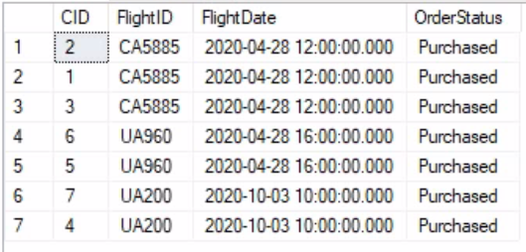

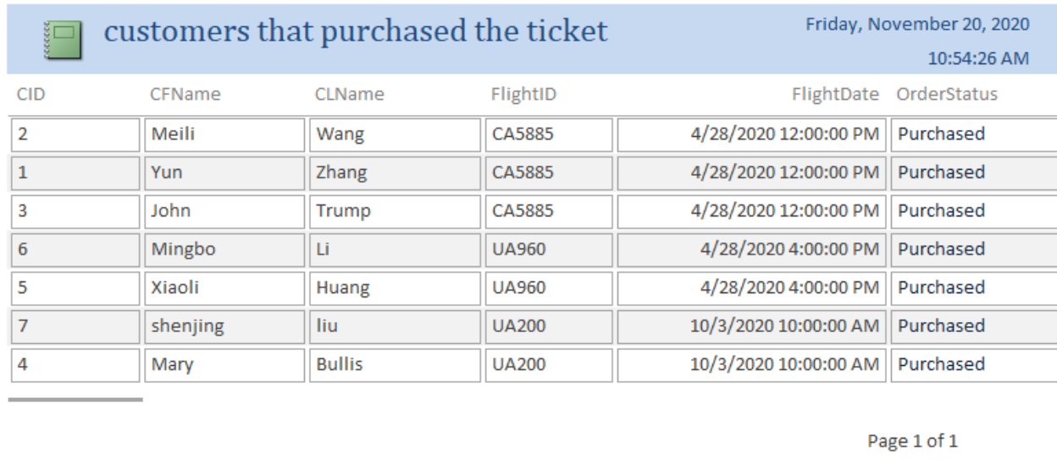

If customer “yunzhang” wants to view the lists. The SQL command will be:

Select * from Customers_order a join MemberCustomer b on a.CID = b.CID where CFName = 'Yun' and CLName = 'Zhang'



2. Because of COVID-19, many customers experienced their flight ticket got cancelled, especially for those traveling from or to China. Therefore, customers may need to look up in the system to ensure the flight they want to purchase has not been cancelled in the past.

-- create views for customers who may want to look up the flight history

Create View flight_history AS

select FlightID, ROUND(((SUM(CASE WHEN Flightservicestatus = 'Cancelled' THEN 1.000 ELSE 0 END)) / COUNT(*)), 2) AS "Cancellation Rate"

from FlightHistory

group by FlightID

--the cancellation rate for each flight ordered by cancellation rate

select *

from flight_history

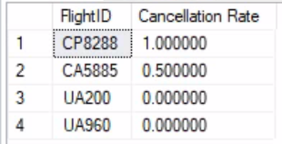order by [Cancellation Rate] desc

1. **Which airlines are favored by most of the customers?**

For our customer behavior analysis, we are interested knowing which route or flight has the most demand.

Create View airlines_summary AS

select a.FlightID,c.ACId,a.OrderStatus,b.Totalflightduration,C.ACName from FlightTransaction a left join Flight b on a.FlightID = b.FlightID join AirlineCompany c on b.ACId = c.ACId

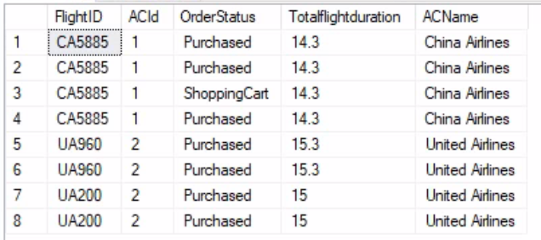

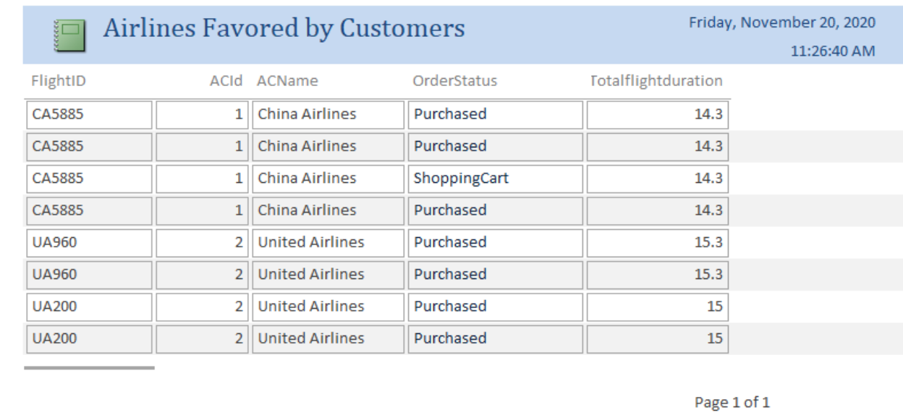

--which airline is the most popular among customers?

select TOP 1 FlightID, count(ACID) as counts

from airlines_summary

group by FlightID

order by counts desc;

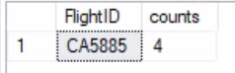

1. **What are the most popular destinations (country)?**

Knowing customers needs may help company contacting with a particular airline and offering customers’ more options

create view airport_summary AS

select CID, FlightID, Arrival_AirportName, Arrival_AirportCity, Arrival_AirportCountry, Departure_AirportName,Departure_AirportCity,Departure_AirportCountry, Totalflightduration,FlightDate,FlightseatID

from (select a.FlightID,b.ArrivalairportId,b.Totalflightduration,b.DepartureAirportId, a.CID,a.FlightDate,a.FlightseatID from FlightTransaction a left join Flight b on a.FlightID = b.FlightID where OrderStatus = 'Purchased') as tmp join Arrival_Airport c on tmp.ArrivalairportId = c.Arrival_AirportId join Departure_Airport d on d.Departure_AirportId = tmp.DepartureAirportId

select * from airport_summary

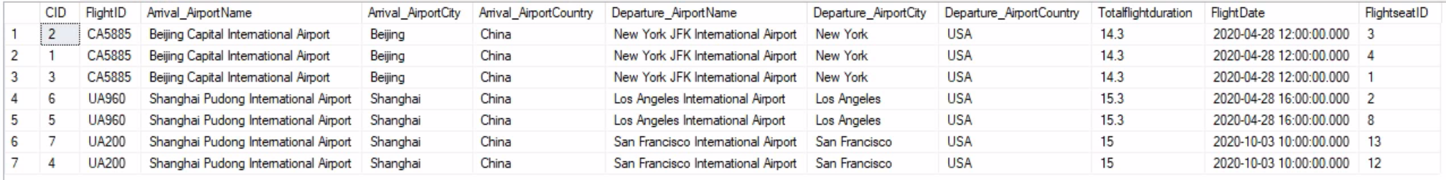

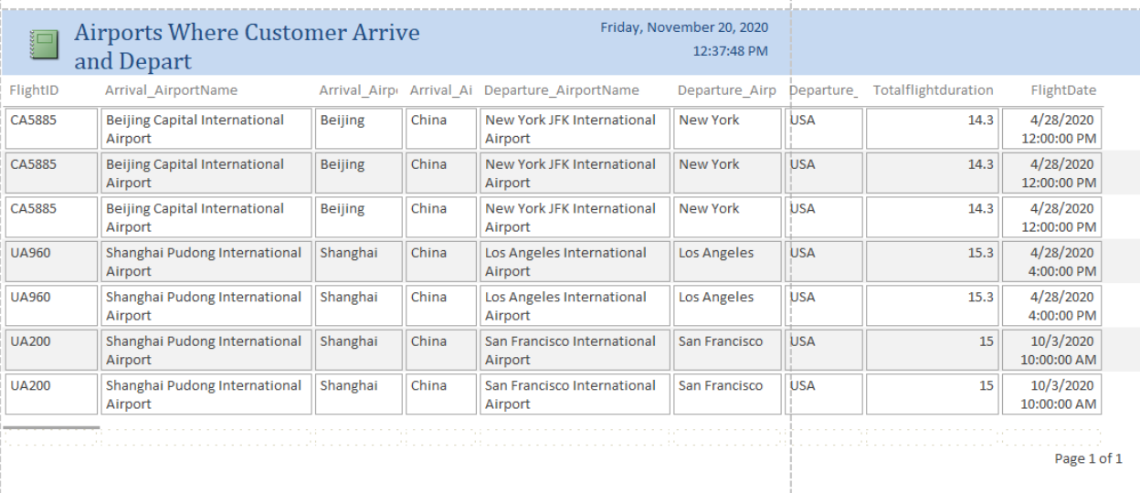

1. **What is the flight itinerary after customers made purchase?**

-- The comfirmation page after the ticket purchased

select b.CFName,b.CLName, FlightID, Arrival_AirportName, Arrival_AirportCity, Arrival_AirportCountry, Departure_AirportName,Departure_AirportCity,Departure_AirportCountry,Totalflightduration,FlightDate,Seatclass,Seatprice

from airport_summary a left join MemberCustomer b on a.CID = b.CID left join (select a.Seatclass,b.FlightseatID,b.Seatprice from FlightSeatclass a join FlightSeat b on a.FlightseatclassID = b.FlightseatclassID) tmp on tmp.FlightseatID = a.FlightseatID

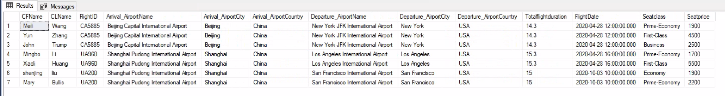

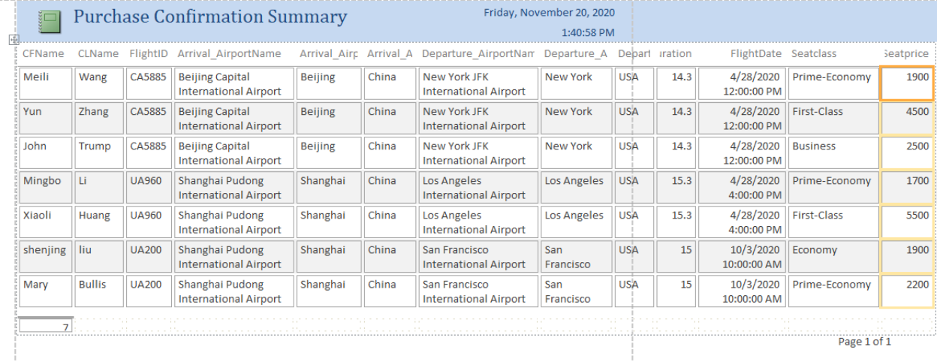

**6. what are some of the seat options left to choose for the customer? What is the seat price for different options?**

-- available seat selection for the flights

create view seat_summary AS

select f.FlightID,Seatclass,Seatprice,Startdate,Enddate from Flight f left join (select a.Seatclass, b.FlightID,b.Seatprice,b.Startdate,b.Enddate from FlightSeatclass a join FlightSeat b on a.FlightseatclassID = b.FlightseatclassID) tmp on f.FlightID = tmp.FlightID

-- display the different seat price for each flight

select FlightID, Seatclass,Seatprice,Startdate,Enddate

from seat_summary

order by FlightID, Seatclass, Seatprice

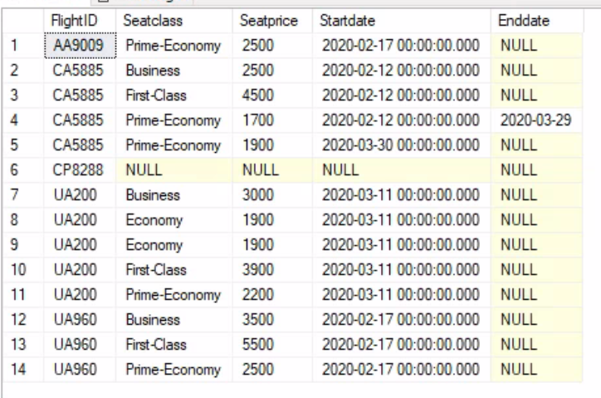

--display the total number of seats option per flight

select FlightID,SUM(CASE WHEN Seatclass = 'First-Class' THEN 1 ELSE 0 END) as first_class_available_seats,SUM(CASE WHEN Seatclass = 'Business' THEN 1 ELSE 0 END) as Business__available_seats,SUM(CASE WHEN Seatclass = 'Prime-Economy' THEN 1 ELSE 0 END) as Prime_economy_available_seats, SUM(CASE WHEN Seatclass = 'Economy' THEN 1 ELSE 0 END) as economy_available_seats

from seat_summary

group by FlightID

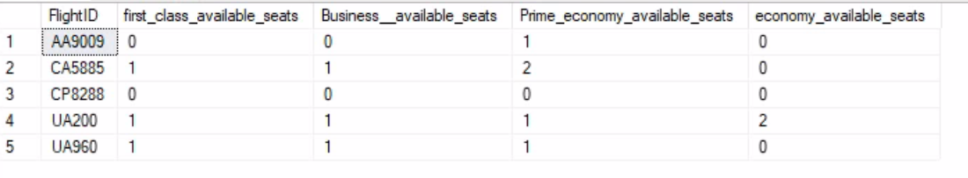

**Interface Implementation - Forms and Reports**

Our users include two groups

1. Company Administrators

2. Company employees

A login page is created to identify different level of access to our system. Company employees can log in with their username and password and administrators as well. They will direct to next page based on the input username. Also, company employees cannot access to queries in MS Access but they can update forms. Administrators can update forms and access to queries and reports.

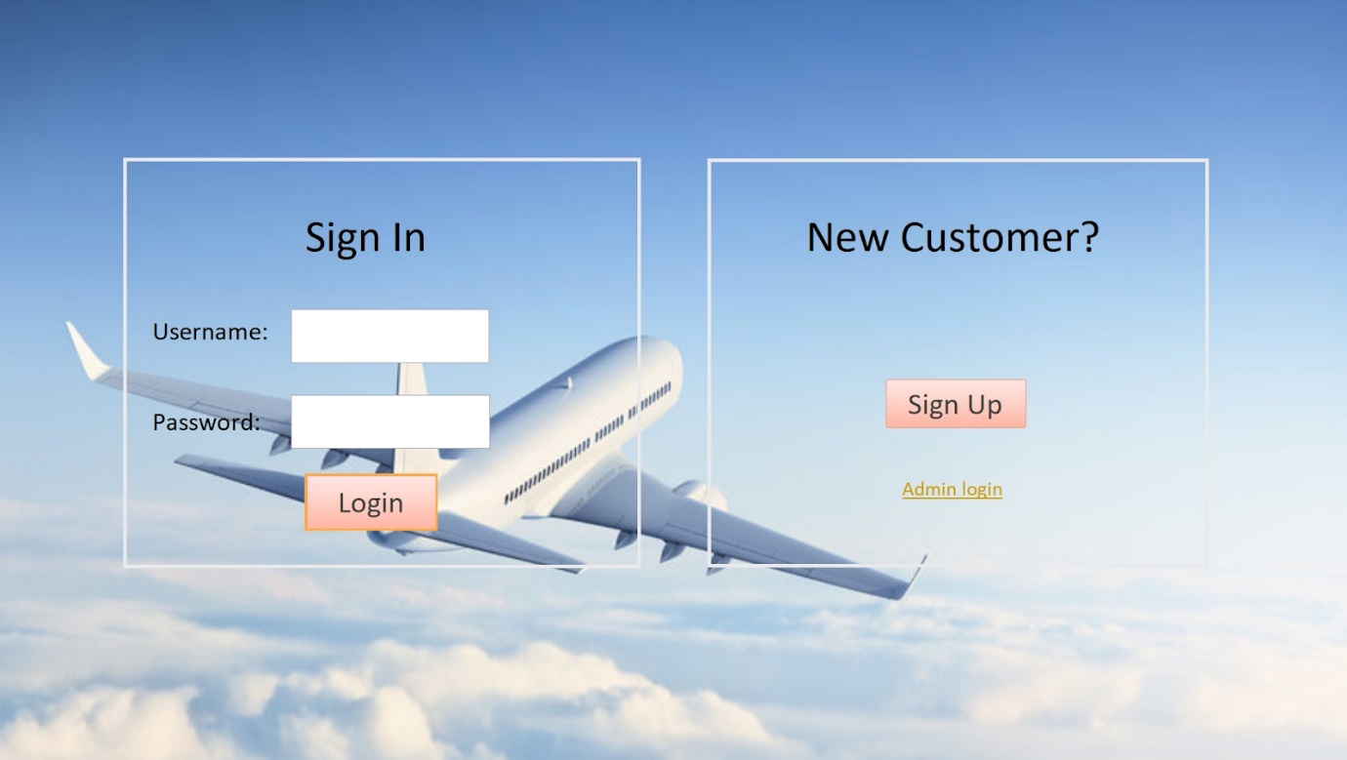

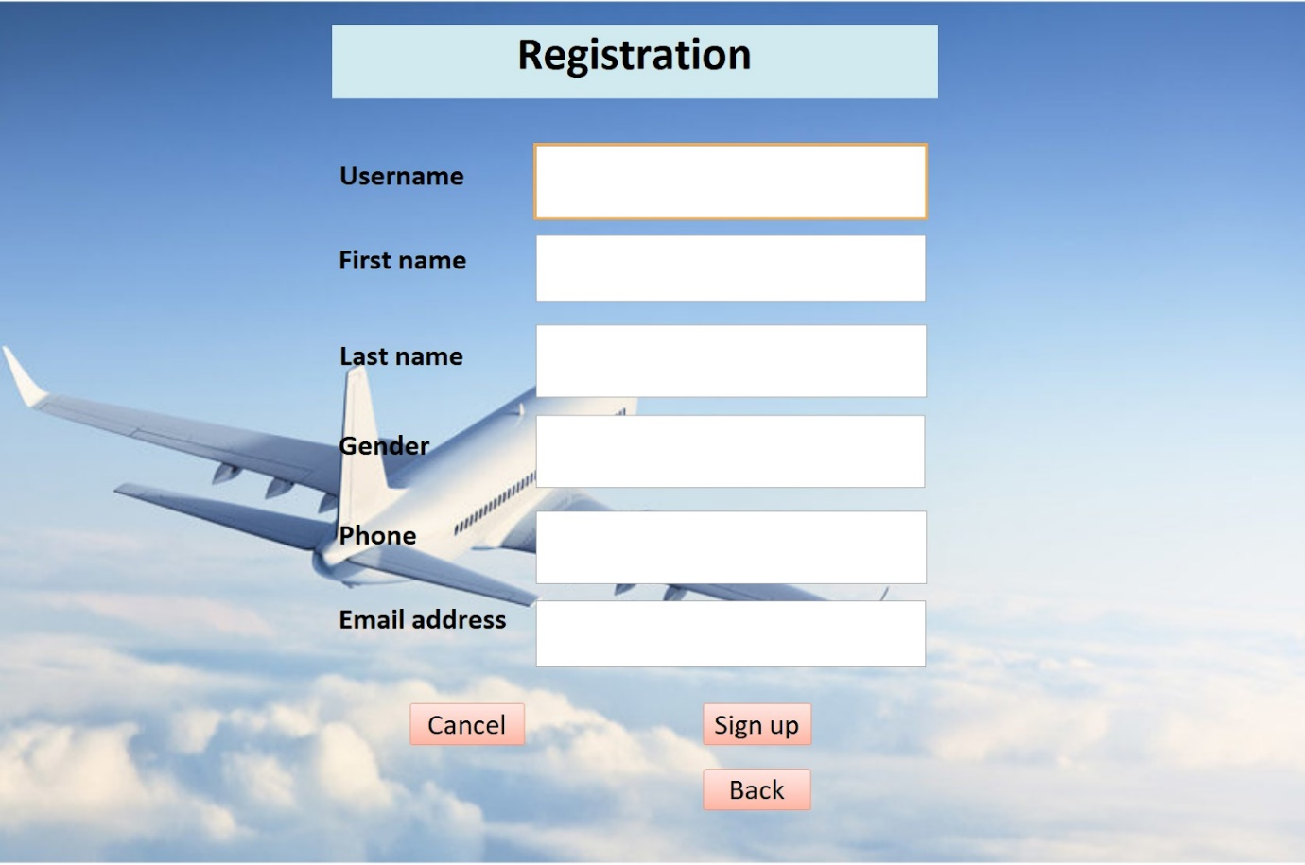

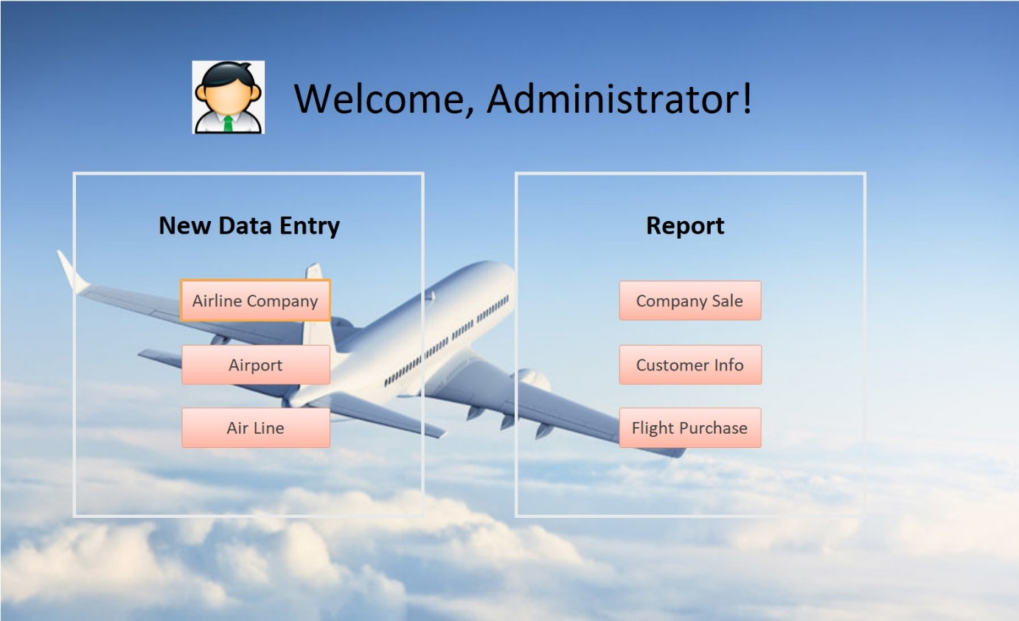

**Airline Company Form:**

User can click each button which directs to the functionality. The sub-form displays flight information associated with the airline company. The sub-form is created by query. Once the airline company offers flights, the sub-form could generate flight information in the airline company form for users to review.

**Arrival Airport and Departure Airport Forms:**

User can add a new arrival airport and review each arrival airport information in both forms.

**Flight Form:**

User can add a new or change an existing flight information. If a user had to check airline company and airport information associated with the flight, the user can click the three navigation buttons and review the needed information. Also, the sub-form is created by query as well, which it exhibits basic information of the flight.

**Flight History Form:**

Users are required to store real-updated information about flights. “Special Instruction” and “Cancellation Reasoning” can be null. Also, “flight service status” column is limited to three inputs; “on time”, “delayed”, and cancelled” for users to select the correct one also the restriction could eliminate input error.

**Flight Seat Class Form:**

User can check and add flight seat class.

**Flight Seat Form:**

User can update flight seat information. For example, when seat price associated with a particular flight is changed, user can update it in the form and generate a new flight seat ID. Also, user can check other associated forms by clicking the blue buttons.

**Member Customer Form:**

User can add and update member customer information.

**Flight Transaction Form:**

User can update and review flight transaction information. The sub-form that is created by query, contains customer and flight information that associated with the particular transaction. Also, when users add a new transaction, the user can review the associated forms by clicking the buttons in which it reduces input error.

**Administrator Query Access:**

Administrators can access, modify, and run queries at any time to review sales of each airline company, visits of airlines, purchase transaction summary and flight seat information.

**Airline Visits Report:**

After administrator run the airline visit query, he or she can review the result and create the outcome into report as the example below.

**Purchase Confirmation Summary Query and Report:**

Administrator can access purchase confirmation summary query and run it into report. It displays customer information, flight information, airport information, and purchased seat information. Administrator can obtain information regard who purchased what flight about how much.

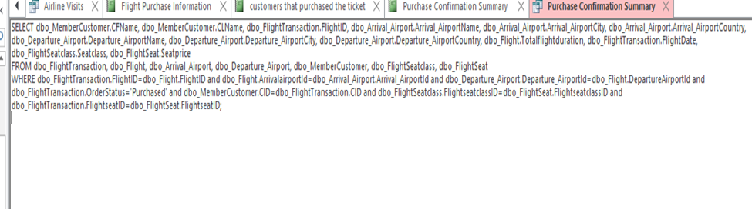

**Airline Company Sale Report:**

The report tells the total sale of each airline company by the date of the query ran.